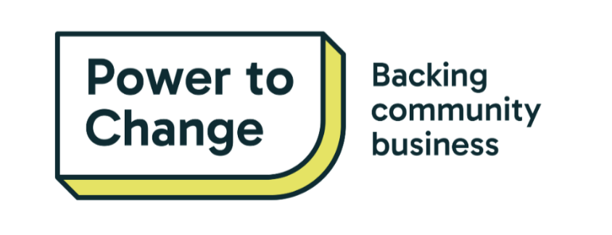

***Press release: For immediate release***

[NAME OF YOUR ORGANISATION]

[Date]

**Headline**

[IMAGE]

[LOCATION IN ALL CAPS, e.g. ‘NORWICH] — [Your organisation's name and short description, i.e. *community organisation Friends of Stretford Hall*] has been selected to participate in the [name of project, *e.g. Community-led High Street Innovators*] project by Power to Change, the think-do tank that backs community business. The project will allow [your organisation’s name] to [one to two sentence description of what you will do as part of your participation in the project].

* **Bullet point 1 with key fact**
* **Bullet point 2 with key fact**
* **Bullet point 3 with key fact**

[Another paragraph about the project, based on information supplied from project lead].

[**Name, title in bold**] said: “Participating in [project name] will [describe what it will allow you to do and what it’ll mean for your community]”

[**Name, title in bold]** at Power to Change, said: “[email project lead for a quote or consult comms guidance email]”

[Can add a short paragraph about next steps and calls to action for the reader, such as visiting your website, signing up for updates, etc.]

Ends

**Notes to Editors**

For more information, interview request and images please contact [Name, Position] via email at [email] or tel. [tel.].

**About**

[**Power to Change**](https://www.powertochange.org.uk/)

Power to Change is the think-do tank that backs community business. We back community business from the ground up. We turn bold ideas into action so communities have the power to change what matters to them.

We know community business works to build stronger communities and better places to live. We’ve seen people create resilient and prosperous local economies when power is in community hands. We also know the barriers that stand in the way of their success.

We’re using our experience to bring partners together to do, test and learn what works. We’re shaping the conditions for community business to thrive.

Power to Change is an organisation with charitable status established in 2015 with a £150m endowment from The National Lottery Community Fund (TNLCF). We received a further £20m from TNLCF in 2021.

[Bluesky](https://bsky.app/profile/powertochange.org.uk) │[Facebook](https://www.facebook.com/powertochangecommunity) | [LinkedIn](https://www.linkedin.com/company/the-power-to-change/)